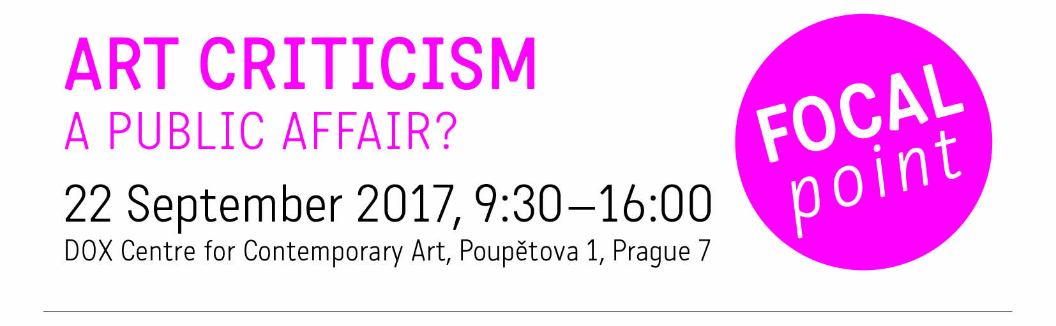
International seminar on the current state of art criticism. Organised by the Arts and Theatre Institute (ATI) in cooperation with the Arts Council Norway and supported by the EEA/Norway Financial Mechanism.

Programme

9.00–9.30 registration

9.30–9.35 official opening (tbc)

9.35–9.42 expert opening
Petr Fischer, journalist, script writer, moderator

9.42–10.00 Presentation of the current state, conditions, challenges and strategic support for the art criticism in the Czech Republic
Karla Hofmannová, music critic, representative of the City of Brno

10.00–10.30 Presentation of the current state, conditions, challenges and strategic support for the art criticism in Norway
Sindre Hovdenakk, Vice-President of the Norwegian Critics’ Association, editor, literature and theater critic

10.30–10.50 Presentation of the current state, conditions, challenges and strategic support for the art criticism in Hungary
Natália Kovács, PhD. student (comparative literature), theatre critic, cultural journalist

10.50–11.00 Support for culture from the Norway Grants Funds
Suzana Jovaševićová, Centre for Foreign Assistance, Ministry of Finance of the Czech Republic
Jan Hrdlička, Dept. of EEA/Norway Funds, Ministry of Culture of the Czech Republic

11.00–11.15 break

11.15–12.30 round tables
a) round tables in Czech moderated by:
Jana Návratová, Dance Section, ATI, dance critic
Martina Pecková Černá, Dept. of International Cooperation, ATI, theatre researcher, translator, arts manager
b) round tables in English moderated by:
Agata Diduszko-Zyglewska (Poland), journalist, cultural activist, political commentator
Sindre Hovdenakk (Norway), Vice-President of the Norwegian Critics’ Association, editor, literature and theater critic

12.30–13.15 break

13.15–14.45 round tables

14.45–15.00 break

15.00–16.00 panel discussion – outputs of the round tables
panelists: moderators of the round tables (Sindre Hovdenakk, Natália Kovács, Jana Návratová and Martina Pecková Černá)
moderator: Rolf Engelsen, senior adviser in the Arts Department of the Arts Council Norway in charge of investigative schemes, art and culture criticism

Note: the introductory and final parts of the seminar will be interpreted (Czech/English), refreshment will be provided.

